McHugh Milieux™
Retractable Wire Knives and Carrier Manual
Ver. 9/01/2016

McHugh Milieux
Sean@mchughmilieux.com
http://mchughmilieux.com

Ph. 630 964 0501

Introduction:
The McHugh Milieux Retractable Wire Knife™ is a tool to be mounted on a small animal stereotaxic instrument. The shaft size fits the standard stereotaxic instruments from Kopf™, Stoelting™ or Leica™.
The purpose of the instrument is to enable planar knife cuts deep in the brain as published by Sclafani , Paxinos, or others dating back to the 1930’s, or rotational cuts as published by Halasz with minimal invasive damage along the track down to the target area.
The McHugh Milieux Model 120 carrier design was originally manufactured by David Kopf Instruments™. The consumable wire knives manufactured by McHugh Milieux are compatible with the Kopf™ carrier. The design for this type of carrier and method of making knives was originally published by Scouten et. al., 1981.
No routine maintenance is useful or required. Where tightening a knob is required, be careful not to overtighten and strip aluminum threads, locking will be achieved with mild hand pressure tightening.

Knife Assemblies:
Model M121 and Model M122 Retractable Wire Knives are used with the McHugh Milieux Model 120 or the Kopf Model 120 Wire Knife Carrier to make cuts (planar lesions or conical rotations) deep in the brain or other soft tissue of research animals, with minimal tissue damage in approach to even a deep starting point.
The retractable wire knife is an assembly of stainless steel tubing, with the upper part free to telescope over the lower assembly. The upper part is rigidly affixed to a tungsten wire long enough to be forced to extend from the bottom of the lower part.
The lower part of the tubing is bent and the bent part cut off so that when the tungsten wire blade is forced to exit out the bottom, it extends laterally in an arc. See the lower end of the center drawing in Figure One. The radius of this curve can be controlled in manufacturing, and customers may specify the approximate extension length before the blade is again pointing vertically. The smaller the radius of the curvature, the shorter the blade life.
Enclosure in stainless steel tubing prevents the .005” diameter tungsten wire knife blade from buckling as it is forced to curve at the end.
Each wire knife can be used several times, but the tip will eventually break from repeated bending; the number of uses can be extended by using the stop nuts and following the procedure below. The blade wire is longer that would ever be used in one extension, and the unused part can then be pushed lower to continue use of that assembly, for 5-10 break offs, depending on how much wire is extended each time.

Figure 1. McHugh Milieux Model 121 wire knife with blade extended,
Model 122 wire knife with blade retracted.

Never separate upper and lower parts so far that the tubing no longer overlaps. You are unlikely to be able to put it back together.
Operation of Carrier:
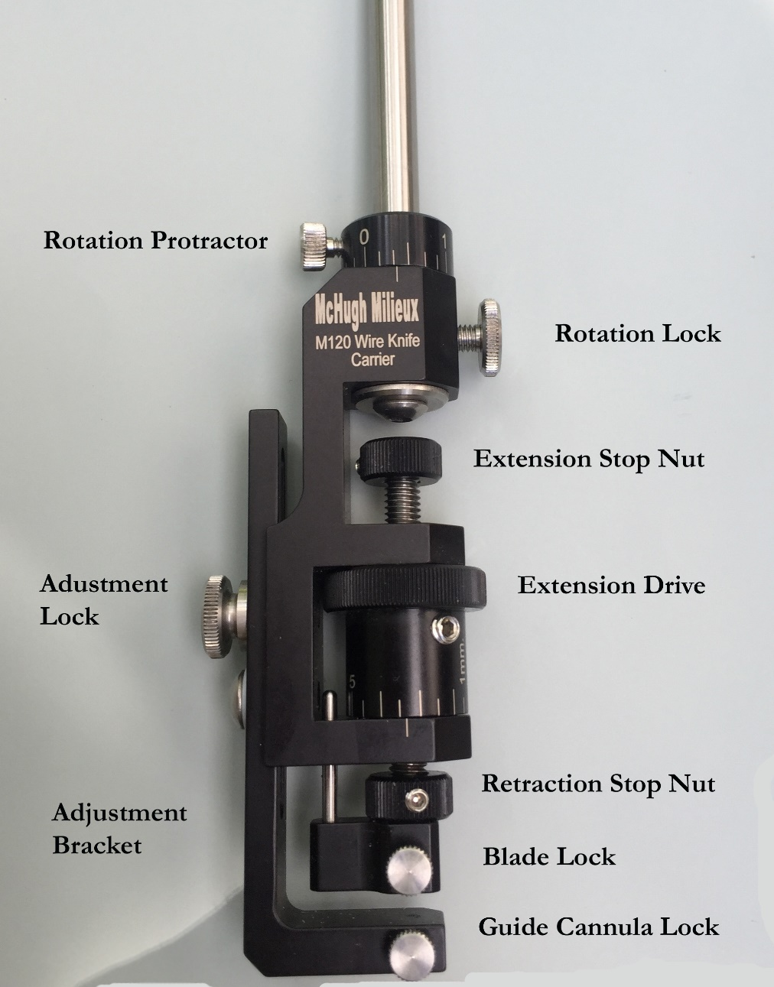
Figure 2. Mc Hugh Milieux Model 120 Retractable Wire Knife Carrier
- Loosen the set screw and rotate the Retraction Stop Nut down against the Blade Lock assembly.
- Rotate the knurled Extension Drive knob until the threaded drive is up as far as it will go.
- Loosen the large thumb screw (Adjustment Lock) on the long arm of the “L” shaped Adjustment Bracket at the bottom of the Model 120 carrier enough so that the bracket can slide vertically. Move it all the way up and relock.
- Loosen the small thumb screws (Blade Lock, Guide Cannula Lock) near the bottom of the Model 120. Thread the knife assembly through the hole in the bottom of the Adjustment Bracket, into the hole in the threaded drive mechanism, until it stops against the top of the hole.
- Tighten the Blade Lock thumbscrew against the thickest layers of tubing on the upper end of the knife assembly.
- Unlock the Adjustment Bracket, and slide it until it is centered on the thickest tubing of the lower part of the knife assembly. Relock the Adjustment Bracket, and tighten the Guide Cannula Lock.
The knife assembly is now securely installed and may be adjusted for optimum usage.
- Loosen the Adjustment Lock and carefully slide the Adjustment Bracket to a point where the wire is bent to come out, and fills the hole, but does not extend outside the hole. If you have difficulty stopping in exactly the correct point, tighten the Adjustment Lock and use the Extension Drive to fine tune the exact retracted flush position.
- Tighten the Adjustment Lock.
- Rotate the Retraction Stop Nut until it stops against the lower body of the carrier. This will limit future retractions to the exact point where the wire is bent and fills the hole, but does not extend outside the hole. This serves two purposes:
  - Not forcing the wire to rebend each time will significantly extend the useful life of the consumable knife assembly.
  - Brain tissue will not ooze into the hole as it passes through, and keeping the blade flush will not cut any more than necessary along the path down to target area.
- Rotate the Extension Drive to push the wire out to the desired distance. Measure and be sure. Then rotate the Extension Stop Nut down until it stops against the upper body of the carrier. This will make it quick and easy to achieve very reproducible knife extensions, without being able to see the tip when is in brain.
- Eventually, after several operations, the wire part being extended will break off or become very floppy. Remove the broken end if it still adheres. There is much still good wire inside the knife assembly. Do this:
  - Without moving the stop nuts, rotate the Extension Drive until it stops against the Retraction Stop Nut.
  - Repeat steps 7 and 8 above.
  - The stop nuts are already set, you can now continue to make several cuts identical to those before the wire broke. When the available wire is used up, replace the consumable knife assembly. You can leave the stop nuts in place if you use the Adjustment Bracket to position the wire at the opening in the lower assembly.
Tips: You may cut on an upward movement, or a downward movement of the Dorsal/Ventral drive on the stereotaxic instrument. The bottom of the wire blade is curved convex. Blood vessels or nerve fibers near the end of the range of the cut could conceivably slide along sloping surface of the wire and deflect outside the range, so as not be cut in one pass. The upper surface of the blade is concave. Any deflection, including both blood vessels and nerve bundles, would be to the inside of the cut. Consider or test what works best in your case. For example, spinal cord cuts may best be done with upward movement.
You may also make cuts by extending the blade, unlocking the Rotation Lock, and rotating by protractor.

